LAB 03
Introduction to Concurrency
OBJECTIVE
Understanding and implementing the concept of concurrency through different mechanisms of multithreading.
Task: 01
- How many threads are running?
3 threads (t1, t2, t3) are created and running concurrently.
- How many tasks are running?
3 tasks, since each thread runs the same task (System.out.println("task one")).
- If more tasks are added than what will be the impact on number of threads?
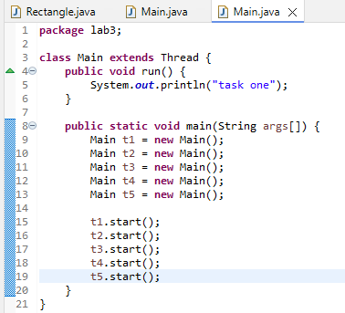

OUTPUT
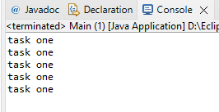
Task: 02
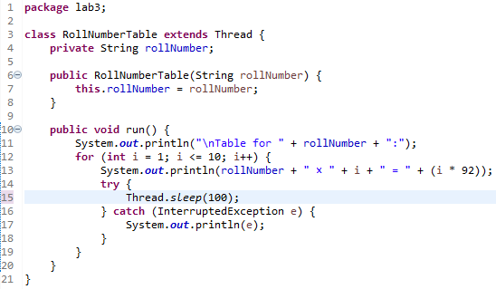
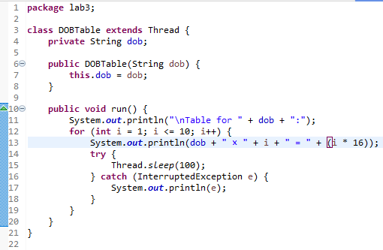
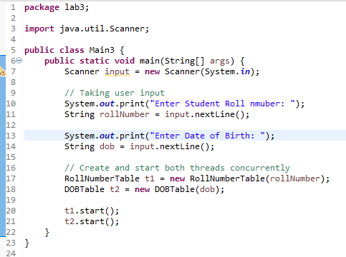
OUTPUT
